How to hosting project with IIS

1. Public project client and server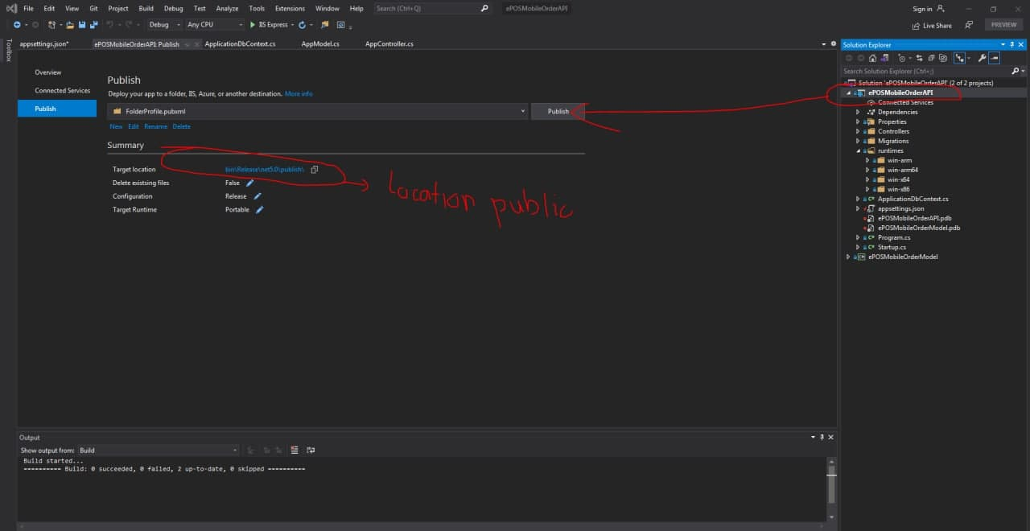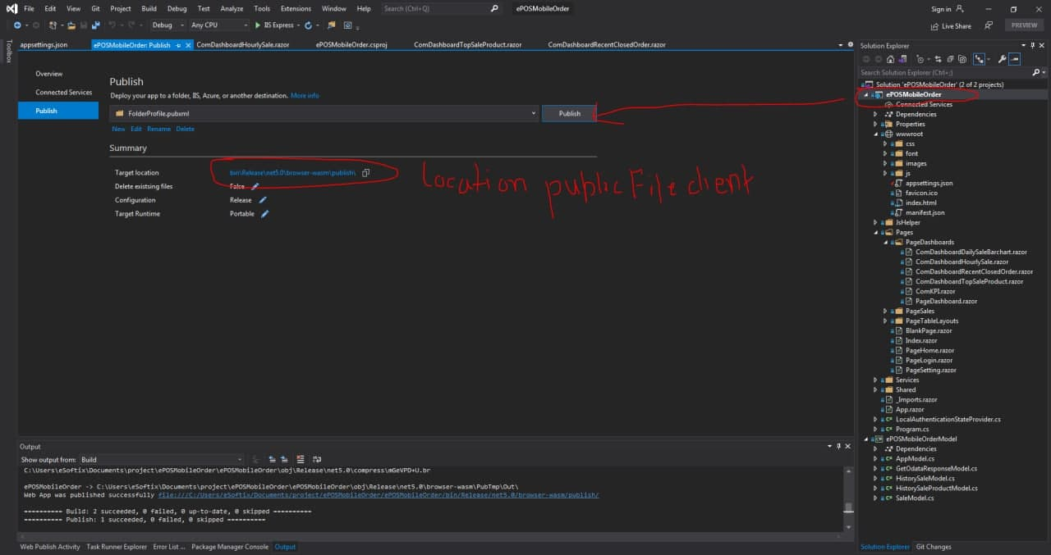
2. Configuration IIS

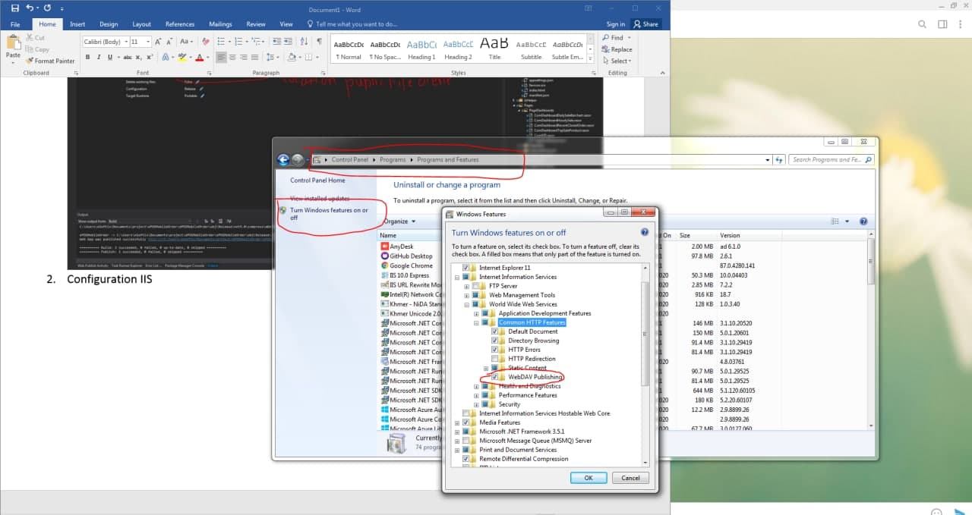

* 1. Create site ,port and find location file that public then click browse(client)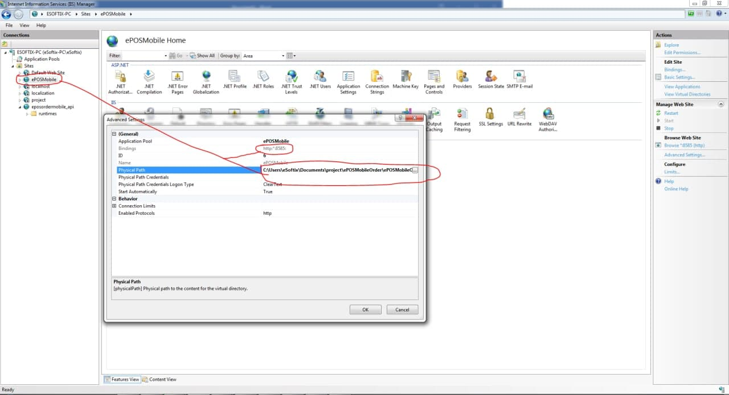
  2. Create site ,port and find location file that public then click browse(api or server)

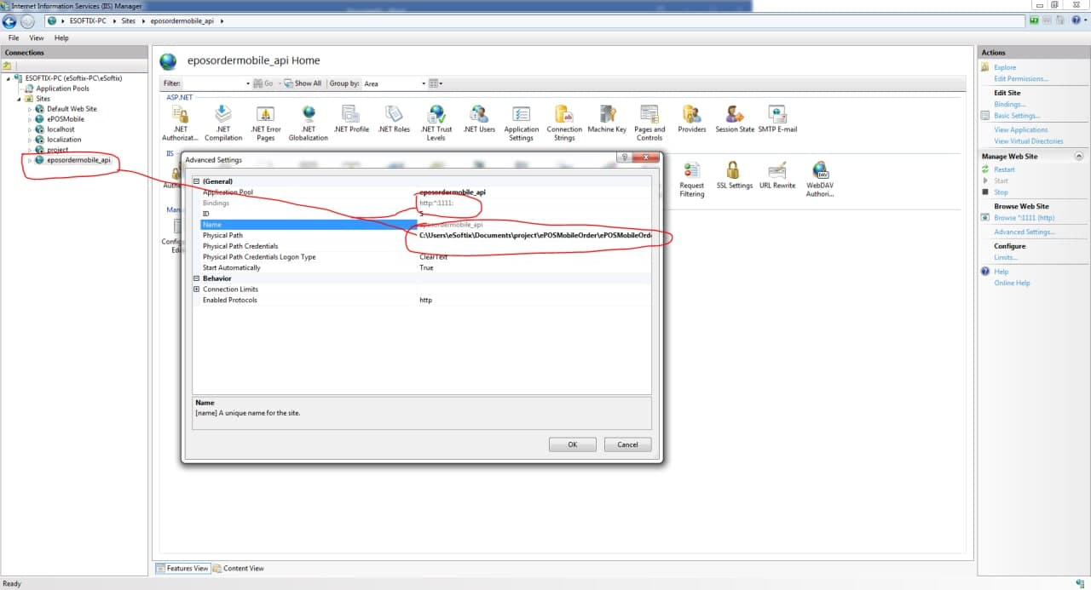

* 1. Allow port client and server(api) on firewall for device access 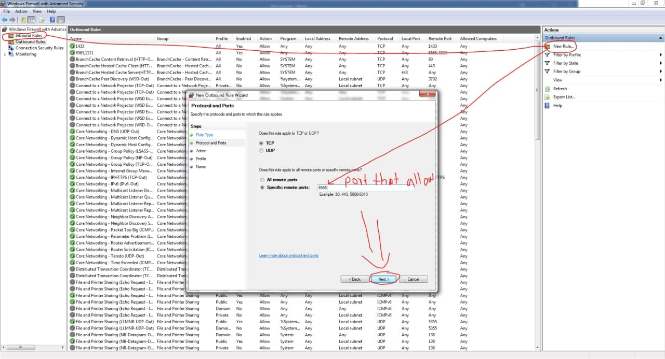

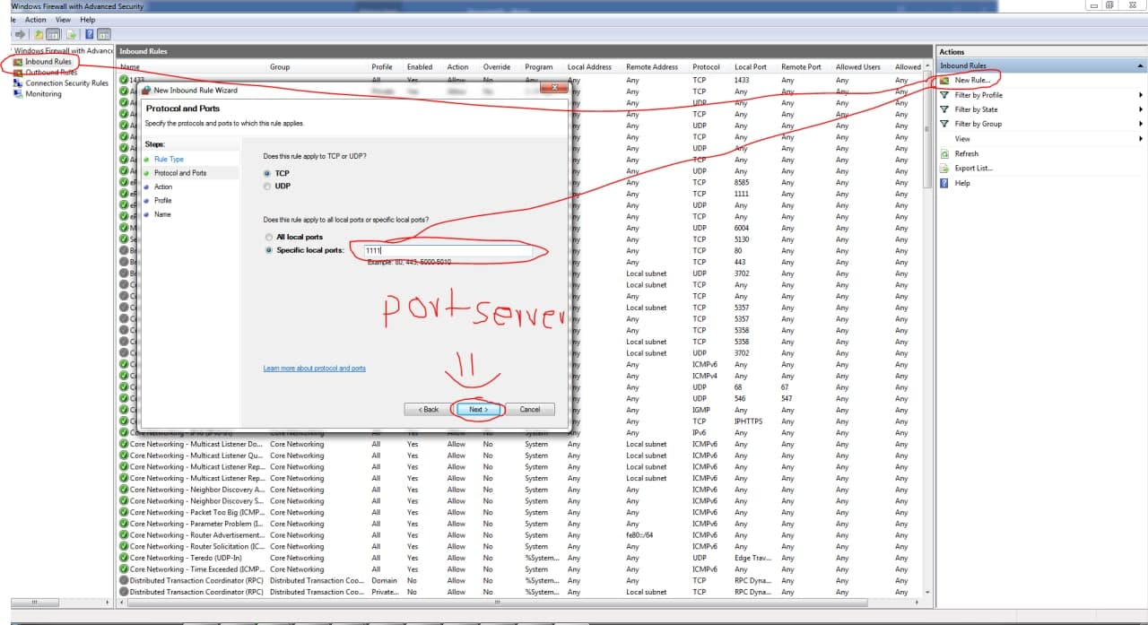

* 1. Install rewrite url file(rewrite_2.0_rtw_x64 for window 7 sp1)
  2. Check url api for device access Find site for client right click ,explore ,click wwwroot folder, double click appsetting.json 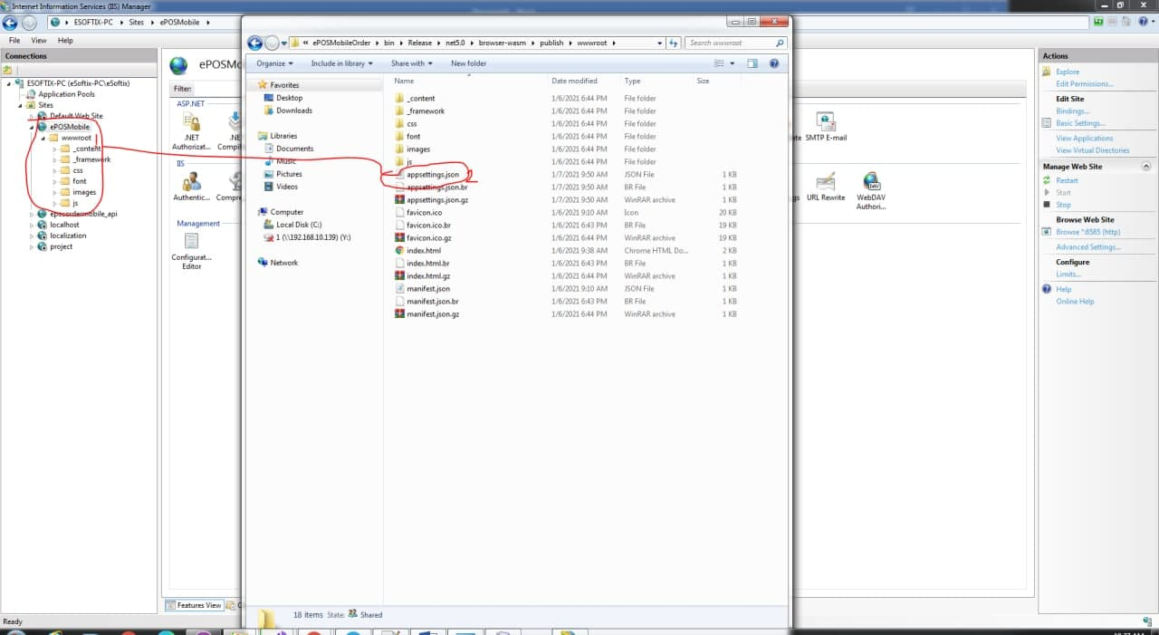

Edit localhost url default to your ip address after edit please public client again:

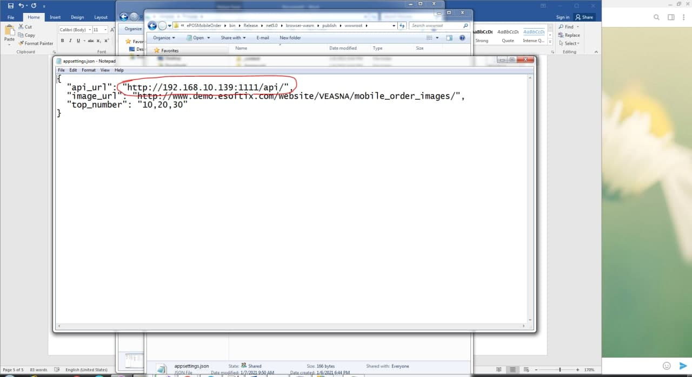

* 1. Note if your project using .net 5 please download hosting bundle 3.2.0 or 3.1.0